**Space Invaders**

<https://github.com/MCKesav/Space-Invaders>

1. Features
2. FIles

from pygame import *

from os import *

# a = input()

font.init()

mixer.init()

#diaplay

WIDTH, HEIGHT = 900, 700

WIN = display.set_mode((WIDTH, HEIGHT))

display.set_caption("Space Invaders")

icon = image.load(path.join('Assets', 'icon.png'))

display.set_icon(icon)

#colors

WHITE = (255, 255, 255)

BLACK = (0, 0, 0)

RED = (255, 0, 0)

YELLOW = (255, 255, 0)

BLUE = (0, 0, 255)

CYAN = (0, 255, 238)

DARK_CYAN = (0, 107, 100)

# black line

BORDER = Rect(WIDTH / 2 - 5, 0, 10, HEIGHT)

#sound

BULLET_FIRE_SOUND = mixer.Sound(path.join('Assets', 'bulletfiresound.mp3'))

BULLET_HIT_SOUNT = mixer.Sound(path.join('Assets', 'gunhitsound.mp3'))

#adding text

HEALTH_FONT = font.SysFont("Bradley Hand ITC", 45, True)

WINNER_FONT = font.SysFont("Bradley Hand ITC", 120, True)

SPACESHIP_SIZE = (65, 45)

FPS = 60

vel = 5

bullets_vel = 7

max_bullets = 3

# health values

player1_health = 10 # TODO

player2_health = 10 # TODO

health_swap_value = 0 # TODO

YELLOW_HIT = USEREVENT + 1

RED_HIT = USEREVENT + 2

#images

YELLOW_SPACESHIP_IMG = image.load(path.join('Assets', 'spaceship_yellow.png'))

YELLOW_SPACESHIP = transform.rotate(

transform.scale(YELLOW_SPACESHIP_IMG, SPACESHIP_SIZE), 90)

RED_SPACESHIP_IMG = image.load(path.join('Assets', 'spaceship_red.png'))

RED_SPACESHIP = transform.rotate(

transform.scale(RED_SPACESHIP_IMG, SPACESHIP_SIZE), 270)

def bg_changer(bg):

space = transform.scale(image.load(path.join('Assets', f's{bg}.webp')),(WIDTH, HEIGHT))

WIN.blit(space, (0, 0))

def draw_window(red, yellow, red_bullets, yellow_bullets, player1_health,player2_health, bg):

bg_changer(bg)

draw.rect(WIN, BLACK, BORDER)

# displaying health

player1_text = HEALTH_FONT.render("Health : " + str(player1_health), 1,WHITE)

player2_text = HEALTH_FONT.render("Health : " + str(player2_health), 1,WHITE)

WIN.blit(player2_text, (WIDTH - player2_text.get_width() - 10, 7))

WIN.blit(player1_text, (10, 10))

#displaying spaceship

WIN.blit(YELLOW_SPACESHIP, (yellow.x, yellow.y))

WIN.blit(RED_SPACESHIP, (red.x, red.y))

#displaying bullets

for bullet in red_bullets:

draw.rect(WIN, RED, bullet)

for bullet in yellow_bullets:

draw.rect(WIN, YELLOW, bullet)

display.update()

def yellow_keys_movements(key_pressed, yellow):

if key_pressed[K_a] and (yellow.x - vel + 4 > 0):

yellow.x -= vel

if key_pressed[K_d] and (yellow.x + vel + yellow.width - 4 < BORDER.x):

yellow.x += vel

if key_pressed[K_w] and (yellow.y - vel - 50 > 0):

yellow.y -= vel

if key_pressed[K_s] and (yellow.y + vel + yellow.height - 4 < HEIGHT):

yellow.y += vel

def red_keys_movements(key_pressed, red):

if key_pressed[K_LEFT] and (red.x - vel + 4 > BORDER.x + BORDER.width):

red.x -= vel

if key_pressed[K_RIGHT] and (red.x + vel + red.width - 4 < WIDTH):

red.x += vel

if key_pressed[K_UP] and (red.y - vel - 50 > 0):

red.y -= vel

if key_pressed[K_DOWN] and (red.y + vel + red.height - 4 < HEIGHT):

red.y += vel

def handle_bullets(yellow_bullets, red_bullets, yellow, red):

for bullet in yellow_bullets:

bullet.x += bullets_vel

#detect collisions

if red.colliderect(bullet):

event.post(event.Event(RED_HIT))

yellow_bullets.remove(bullet)

elif bullet.x > WIDTH:

yellow_bullets.remove(bullet)

for bullet in red_bullets:

bullet.x -= bullets_vel

#detecting collisions

if yellow.colliderect(bullet):

event.post(event.Event(YELLOW_HIT))

red_bullets.remove(bullet)

elif bullet.x < 0:

red_bullets.remove(bullet)

def draw_winner(text):

draw_winner_text = WINNER_FONT.render(text, 1, WHITE)

WIN.blit(draw_winner_text, (WIDTH / 2 - draw_winner_text.get_width() / 2, HEIGHT / 2 - draw_winner_text.get_height() / 2))

display.update()

time.delay(5000)

#cheatcode for reset

def reset(bg, health_reset_value1, health_reset_value2): # TODO

global player1_health

global player2_health

global health_swap_value

if player1_health > 10:

player1_health = 10

if player2_health > 10:

player2_health = 10

if health_swap_value & 1 == 1:

player1_health, player2_health = player2_health, player1_health

health_swap_value -= 1

if health_reset_value1 == 1:

player1_health -= 5

if health_reset_value2 == 1:

player2_health -= 5

bg_changer(0)

def main():

bg = 0

if bg == 0:

bg_changer(0)

red = Rect(675 - SPACESHIP_SIZE[0] / 2, 300, SPACESHIP_SIZE[0] - 17,SPACESHIP_SIZE[1] + 20)

yellow = Rect(450 / 2 - SPACESHIP_SIZE[0] / 2, 300, SPACESHIP_SIZE[0] - 17,SPACESHIP_SIZE[1] + 20)

red_bullets = []

yellow_bullets = []

health_reset_value1 = 0

health_reset_value2 = 0

vel = 5

bullets_vel = 7

max_bullets = 3

global player1_health # TODO

global player2_health # TODO

global health_swap_value # TODO

clock = time.Clock()

run = True

#running loop

while run:

clock.tick(FPS)

for evt in event.get():

if evt.type == QUIT:

run = False

if evt.type == KEYDOWN:

if evt.key == K_LCTRL and len(yellow_bullets) < max_bullets:

bullet = Rect(yellow.x + yellow.width,yellow.y + yellow.height / 2 - 2, 10, 5)

yellow_bullets.append(bullet)

BULLET_FIRE_SOUND.play()

if evt.key == K_RCTRL and len(red_bullets) < max_bullets:

bullet = Rect(red.x, red.y + red.height / 2 - 2, 10, 5)

red_bullets.append(bullet)

BULLET_FIRE_SOUND.play()

# Cheat Codes

if evt.key == K_1:

player1_health += 5

if player1_health < 10 and player1_health - 5 != 0:

health_reset_value1 = 1

else:

health_reset_value1 = 0

if evt.key == K_0:

player2_health += 5

if player2_health < 10 and player2_health - 5 != 0:

health_reset_value2 = 1

else:

health_reset_value1 = 0

if evt.key == K_2 and player2_health - 5 > 0:

player2_health -= 5

if evt.key == K_9 and player1_health - 5 > 0:

player1_health -= 5

if evt.key == K_h:

health_swap_value += 1

player1_health, player2_health = player2_health, player1_health

if evt.key == K_b:

if bg == 5:

bg = 0

bg_changer(0)

else:

bg += 1

bg_changer(bg)

if evt.key == K_r:

bg = 0

reset(bg, health_reset_value1, health_reset_value2)

#deducting health

if evt.type == YELLOW_HIT:

player1_health -= 1

BULLET_HIT_SOUNT.play()

if evt.type == RED_HIT:

player2_health -= 1

BULLET_HIT_SOUNT.play()

#display winner

winner_text = ''

if player1_health <= 0:

winner_text = "Player 2 wins"

if player2_health <= 0:

winner_text = "Player 1 wins"

if winner_text != '':

draw_winner(winner_text)

break

key_pressed = key.get_pressed()

yellow_keys_movements(key_pressed, yellow)

red_keys_movements(key_pressed, red)

handle_bullets(yellow_bullets, red_bullets, yellow, red)

draw_window(red, yellow, red_bullets, yellow_bullets, player1_health,player2_health, bg)

if __name__ == "__main__":

main()

Features

|  |  |
| --- | --- |
| **Player 1** | **Player 2** |
| **Controls** | **Controls** |
| ‘W’ for moving spaceship up | ‘Up key’ for moving spaceship up |
| ‘S’ for moving spaceship down | ‘Down key’ for moving spaceship down |
| ‘A’ for moving spaceship left | ‘Left key’ for moving spaceship left |
| ‘D’ for moving spaceship right | ‘Right key’ for moving spaceship right |
| ‘Left CTRL’ for shooting the bullets | ‘Right CTRL’ for shooting the bullets |
| **Cheat Codes** | **Cheat Codes** |
| ‘1’ for increasing your health by 5 | ‘0’ for increasing your health by 5 |
| ‘2’ for decrease other player’s health by 5 | ‘9’ for decrease other player’s health by 5 |

|  |
| --- |
| **Other Cheat Codes** |
| ‘B’ To change the background image (you can choose from 6 different backgrounds) |
| ‘R’ To undo the cheat codes |
| ‘H’ To swap the player’s health |

Files

Logo

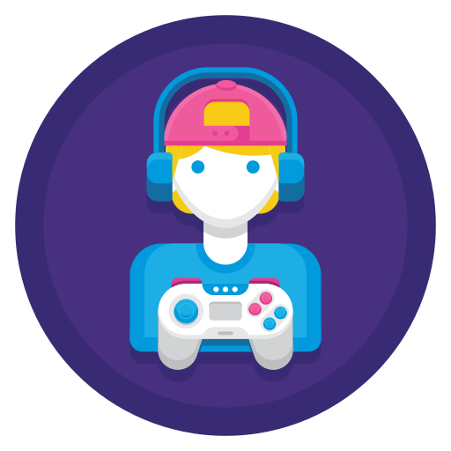

backgrounds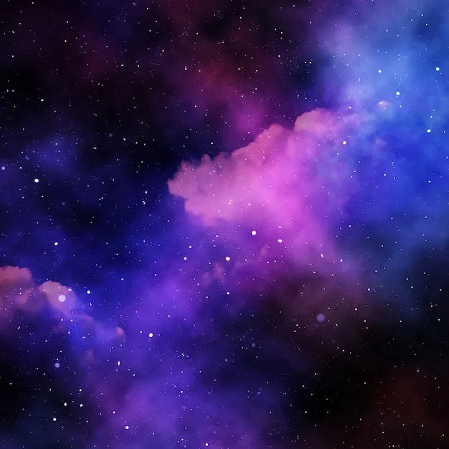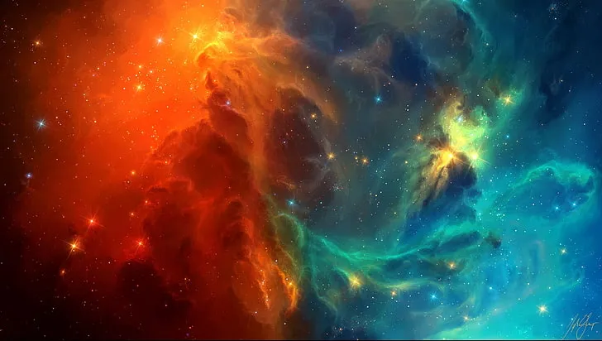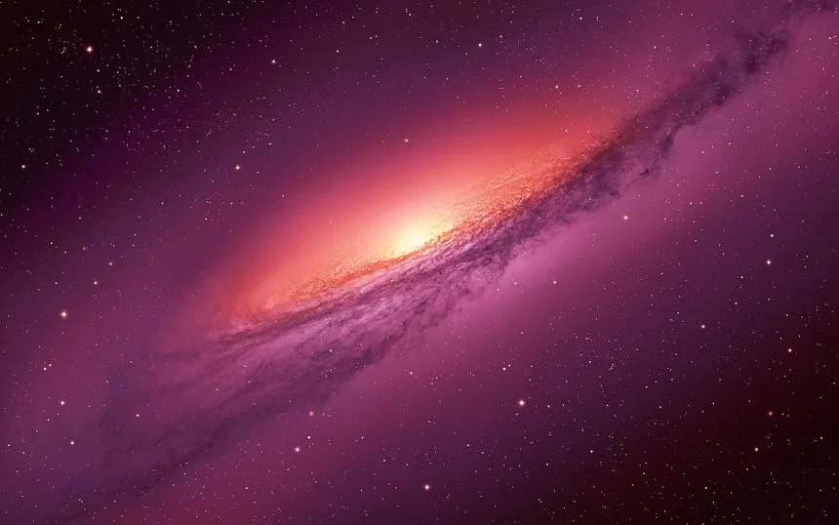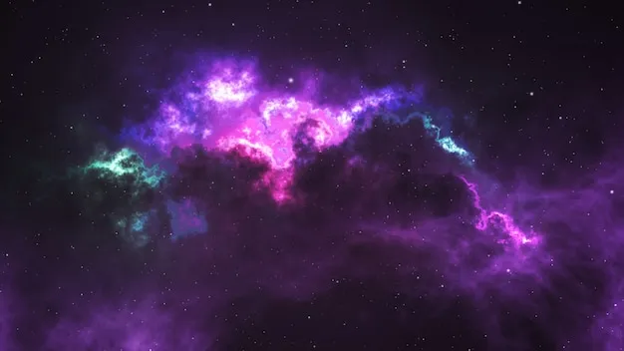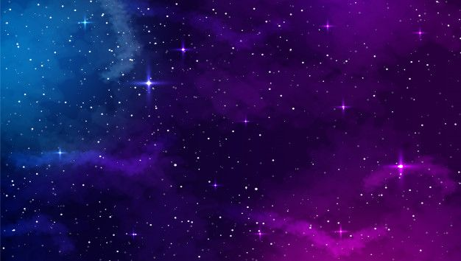

spaceships

red spaceship

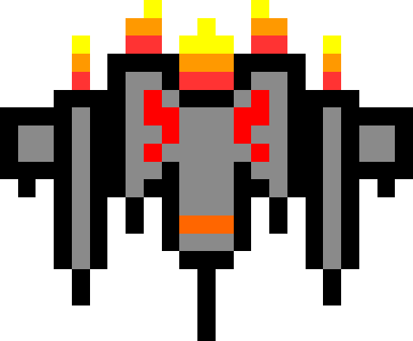

Yellow spaceship

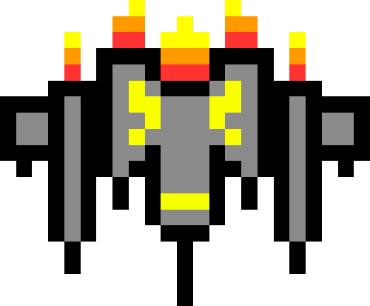

Mp3



The main code



The video

